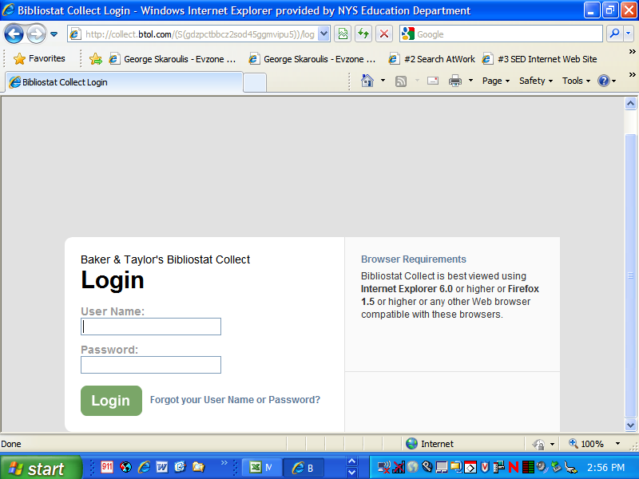
The URL to access the annual report is http://collect.btol.com.
Type in the library’s User Name and Password, then click on “Login”. If you have misplaced your User Name and Password, please contact your library system.
Note the browser requirements. Collect is supported on both MAC and Windows operating systems. Collect is best viewed in Microsoft Internet Explorer 6.0 or higher, or Foxfire 1.5 or higher, and when screen resolution is set at 1024 x 768 pixels or higher.
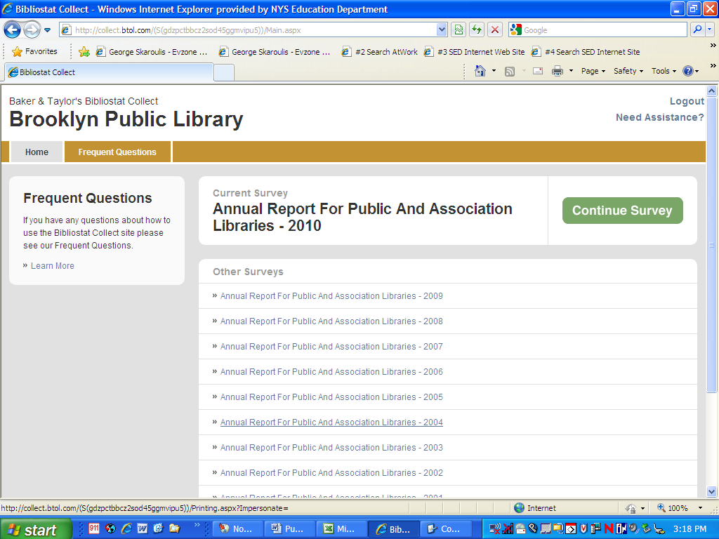
Listed under “Other Surveys” are links to read-only copies of previously submitted annual reports.
Active (unsubmitted) annual reports are listed in the “Current Survey” section. To access the annual report, click on the “Continue Survey” button.
For detailed information about the software’s functionality, formerly found in “Documentation”, click on “Frequent Questions” or “Learn More”. Information is arranged by general topics.
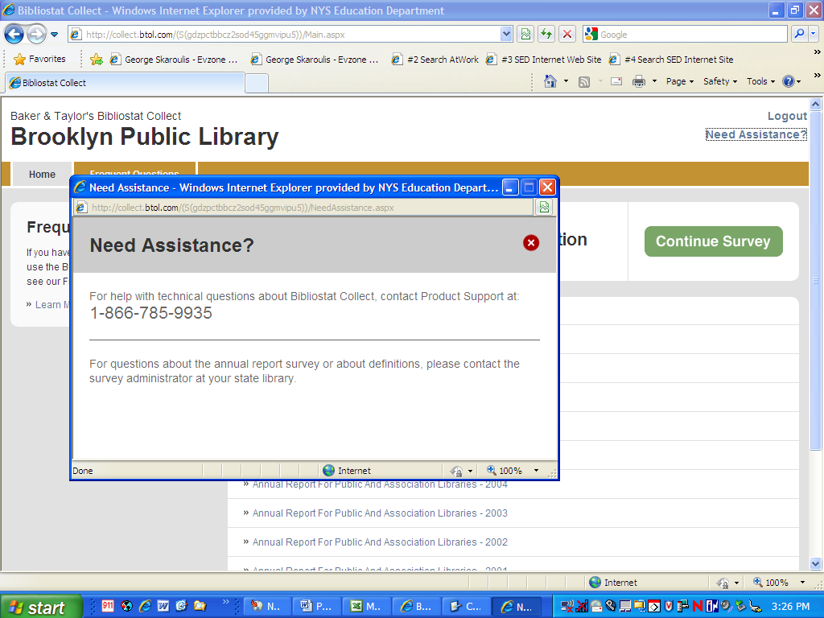
The toll-free telephone number for Product Support is found by clicking on “Need Assistance?” Product Support is available Monday through Friday from 9:00 a.m. to 6:00 p.m. (Eastern).

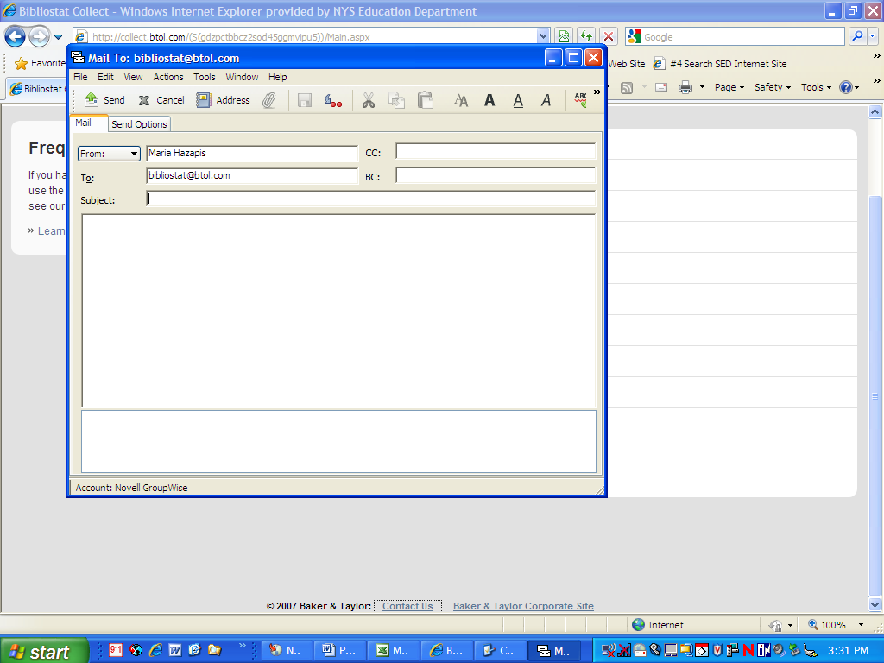
Clicking on “Contact Us” at the bottom of the screen will allow the library to send an email to Product Support at Bibliostat@btol.com.
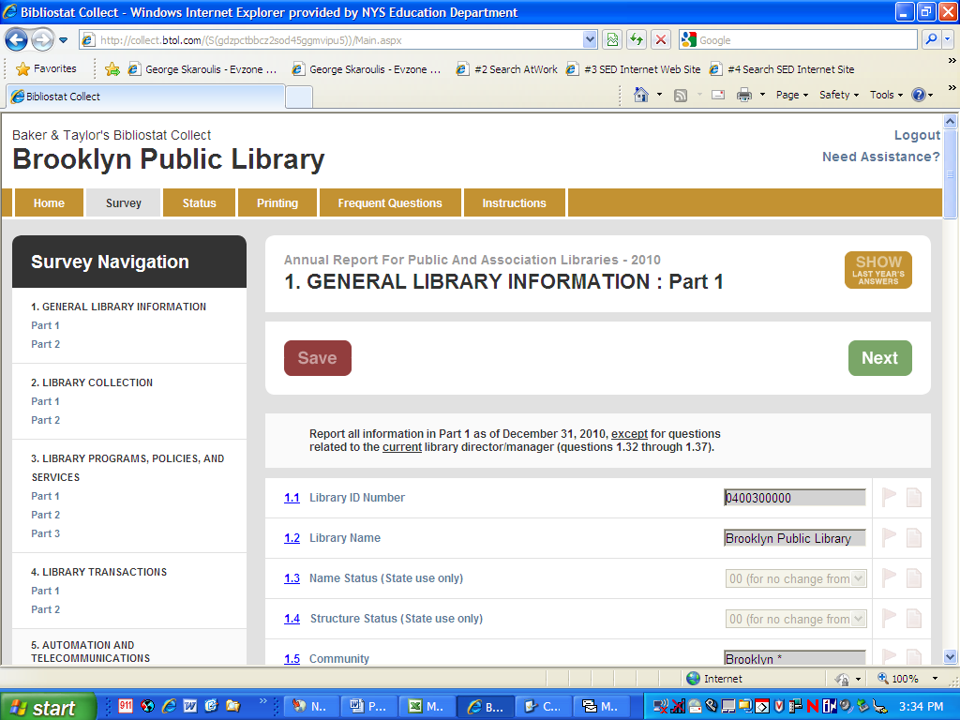
By clicking on “Show Last Year’s Answers”, last year’s data (if available) will appear above the data entry fields (see next page).
“Survey Navigation” has links to the various sections of the annual report. It is not necessary to complete the annual report in the order shown. Users may click on any link at any time to enter data. The software will not allow the user to submit the annual report until all required questions have been completed.
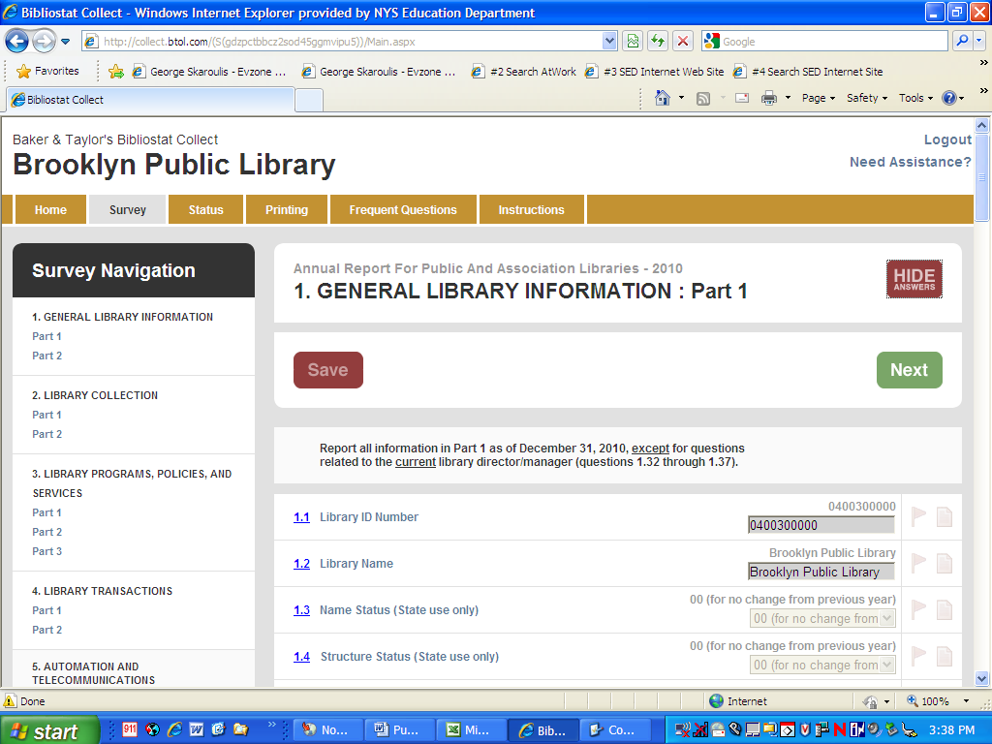
Clicking on “Hide Answers” will hide last year’s answers so they do not appear above the data entry fields (see previous page).
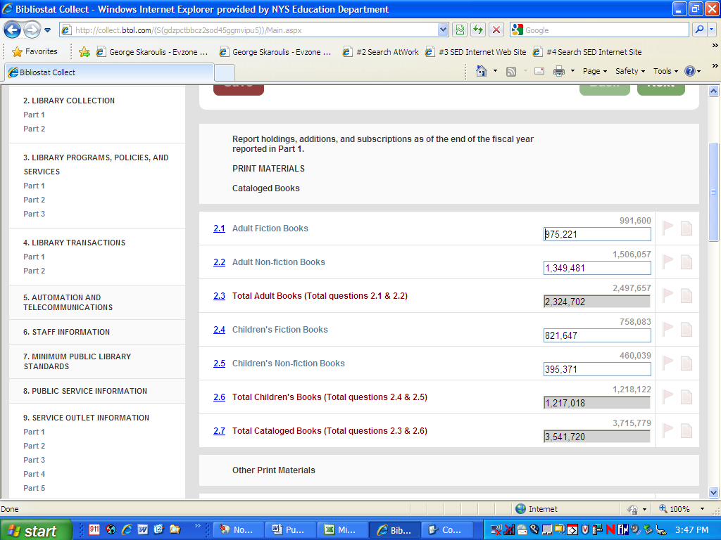
Within the survey (right) section of the screen, there are five “columns”:
the question number; the question; the answer field for this year’s response; a flag icon; and a note icon.
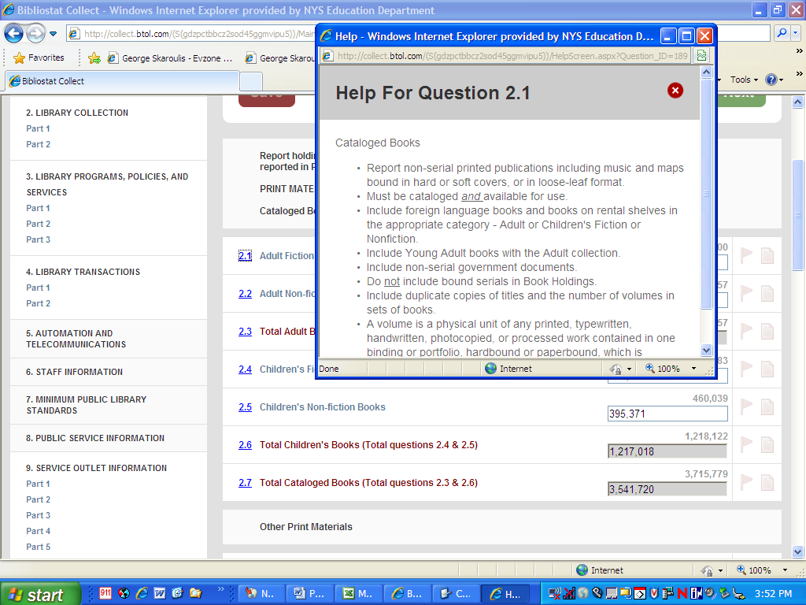
If a question number is underlined, there is a definition associated with the question. Clicking on the question number will open a text box with the definition for that question.
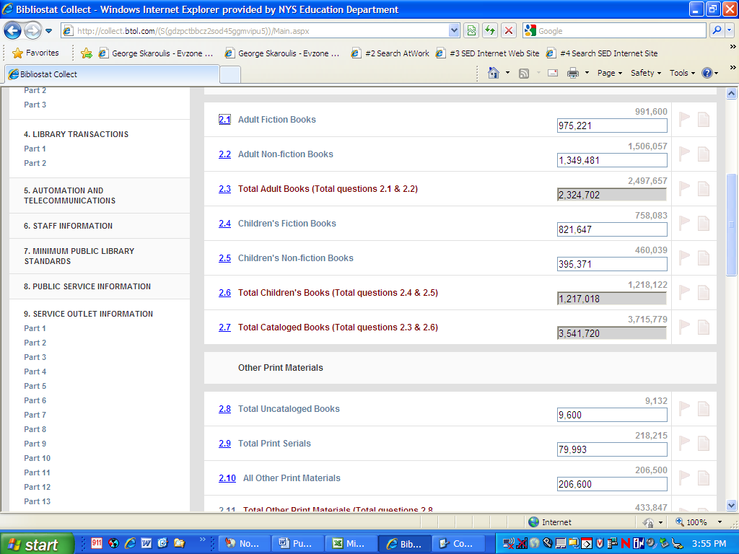
Questions in dark red text are automatic totals.
Grey fields indicate that the fields are calculated or locked, and can not be manually changed.
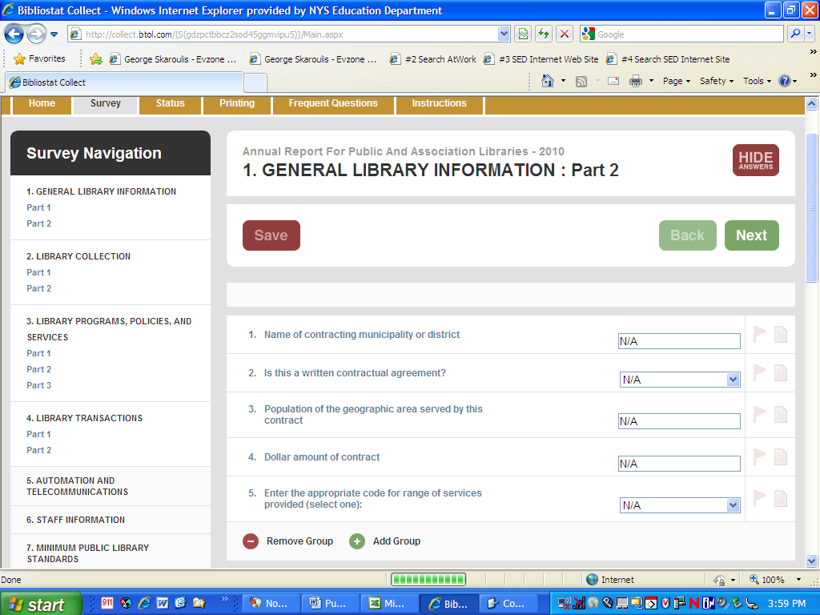
Repeating groups allow the user to customize the report to provide detailed information. As many groups for the same question may be added, as needed.
If there are blank or unwanted groups of questions, clicking on “Remove Group” will delete the extra response boxes.
If a question does not apply, one group must be completed with “N/A” in each data entry box.
Note: Collect does not have an “Undo” button; once a repeating group has been removed, the user can not retrieve the lost data.
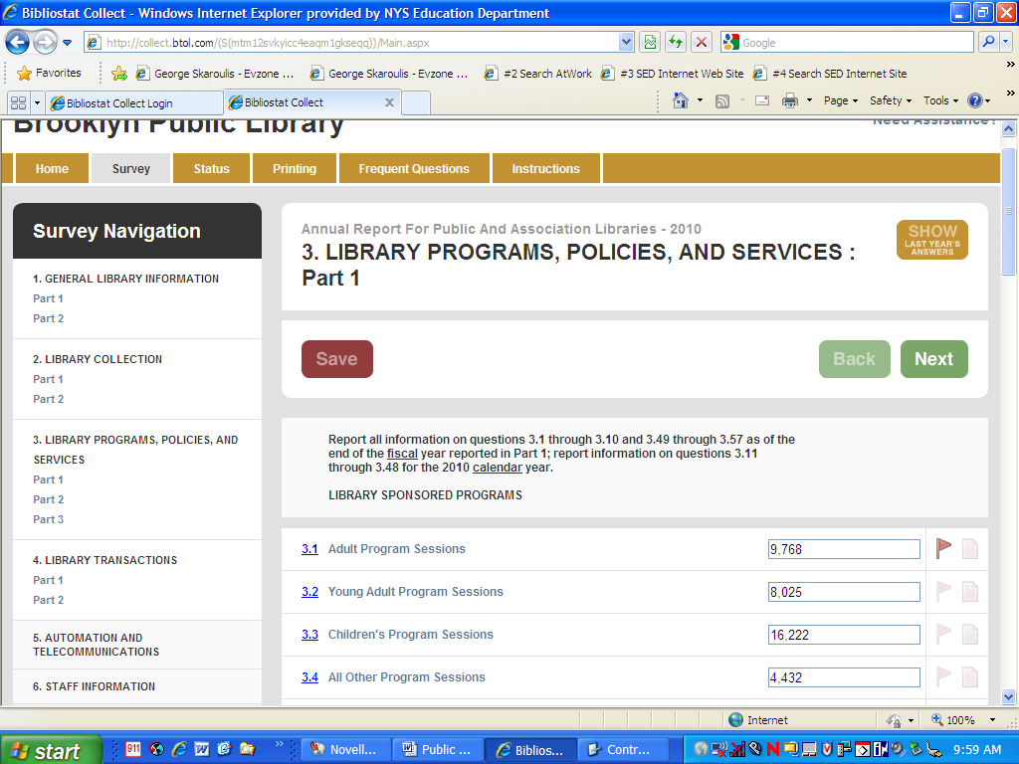
Clicking on the flag icon will either turn it on or off. This option may be used to create a reminder for the user to return to the question at some other time. To view all flagged questions, select “Status” on the navigation bar at the top of the page, then select “View All Flagged Questions”.
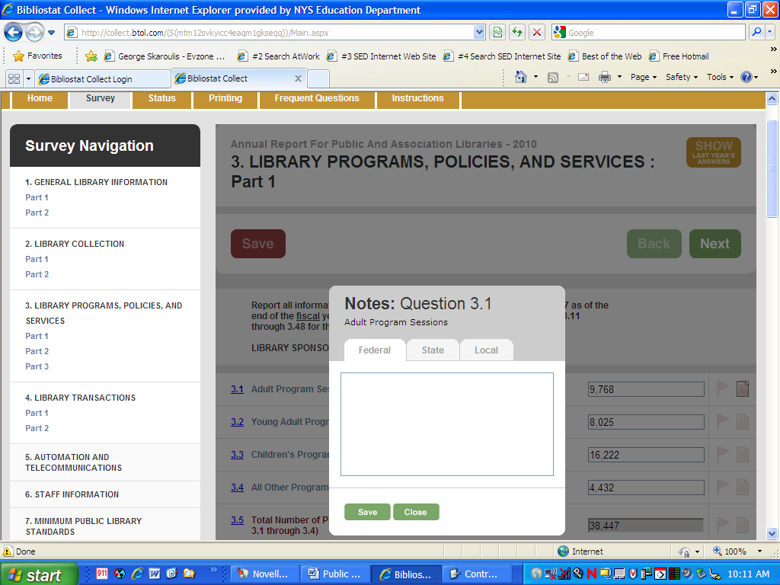
Clicking on the note icon will open a note pad. This allows the user the option of entering a “Local” note (a reference note for the user), a “State” note for the State Library, or a “Federal Note” to satisfy a federal edit check. If information is saved on any tab, the note pad will become highlighted. The note pad defaults to the “Federal” note; click on the State or Local tab to enter notes on those “pages”. There is an option under “Printing” that will allow the user to view and/or print all the notes entered. To view all the annotations, select “Printing” on the navigation bar at the top of the page, then select “Print Annotation Reports” (see page 21).
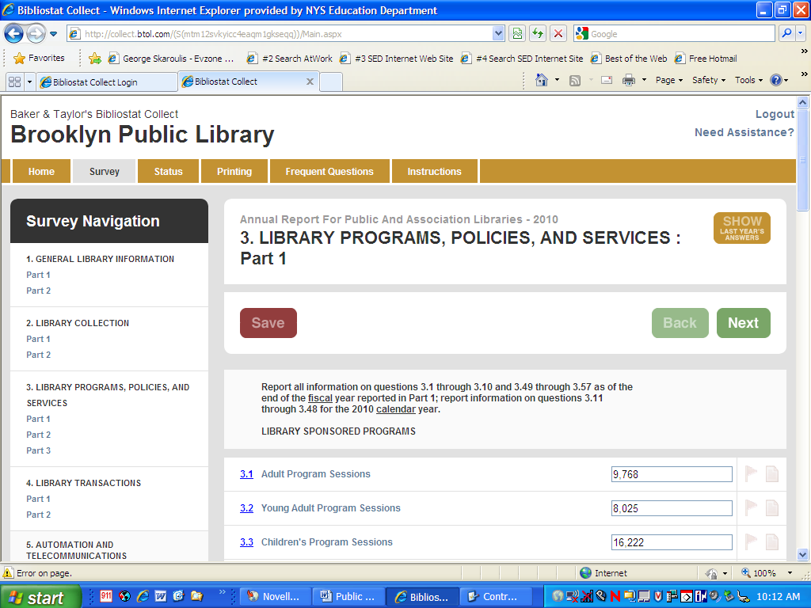
After entering data, clicking on the “Save” button at the top or …
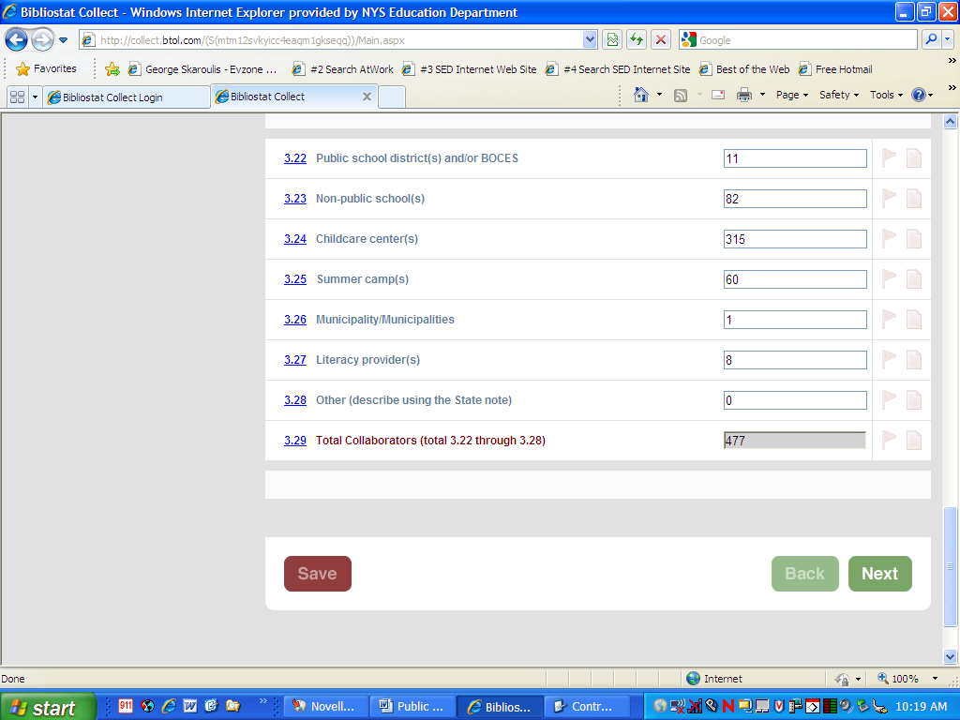
… bottom of the screen completes all calculations, saves the data, and refreshes the page. Clicking on the “Back” or “Next” buttons, or any of the links in “Survey Navigation”, also completes calculations and saves data, but takes the user to the previous or next section of the survey, or to the section selected. Users are encouraged to click on the “Save” button on each page before proceeding to another section of the survey.
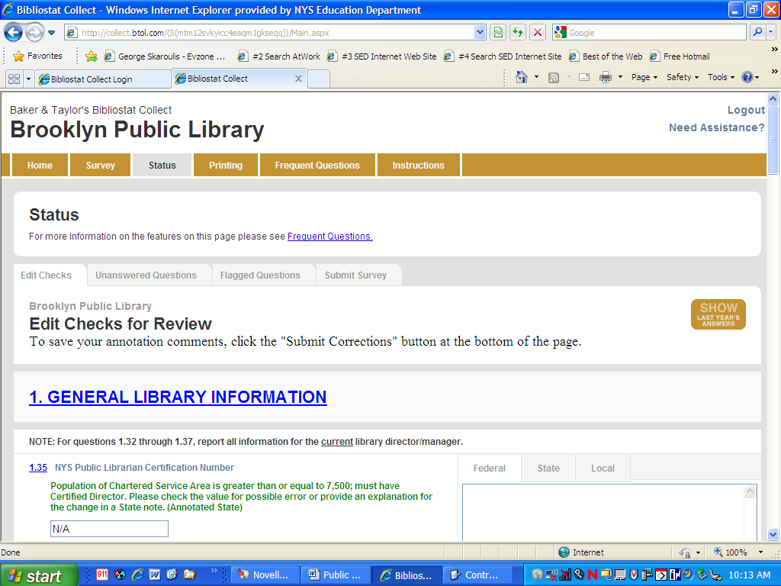
After completing all the sections of the annual report, click on “Status”. From this screen, complete these steps:

- View edit checks
- View all required unanswered questions
- View flagged questions
- Submit the annual report
Clicking on the “Edit Checks” tab will allow the user to view all edit checks and enter Federal, State, and/or Local notes from the Edit Check page. Answers may be entered from this screen – there is no need to go back to the annual report. If the edit check is on an automatic total and the figure is incorrect, you will need to correct the data in the contributing questions.

Edit checks have been developed by the State Library to alert users when there is a problem with the data.

When the edit check report is generated, the question and edit condition will display.
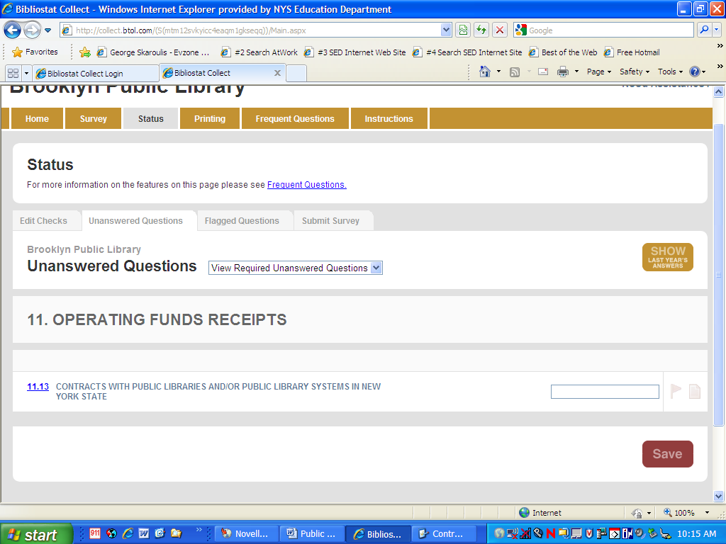
Clicking on the “Unanswered Questions” tab will create a list of questions that must be answered before submitting the annual report. Users should be certain that “View Required Unanswered Questions” is selected from the drop-down menu. Answers may be entered from this screen – there is no need to go back into the annual report.
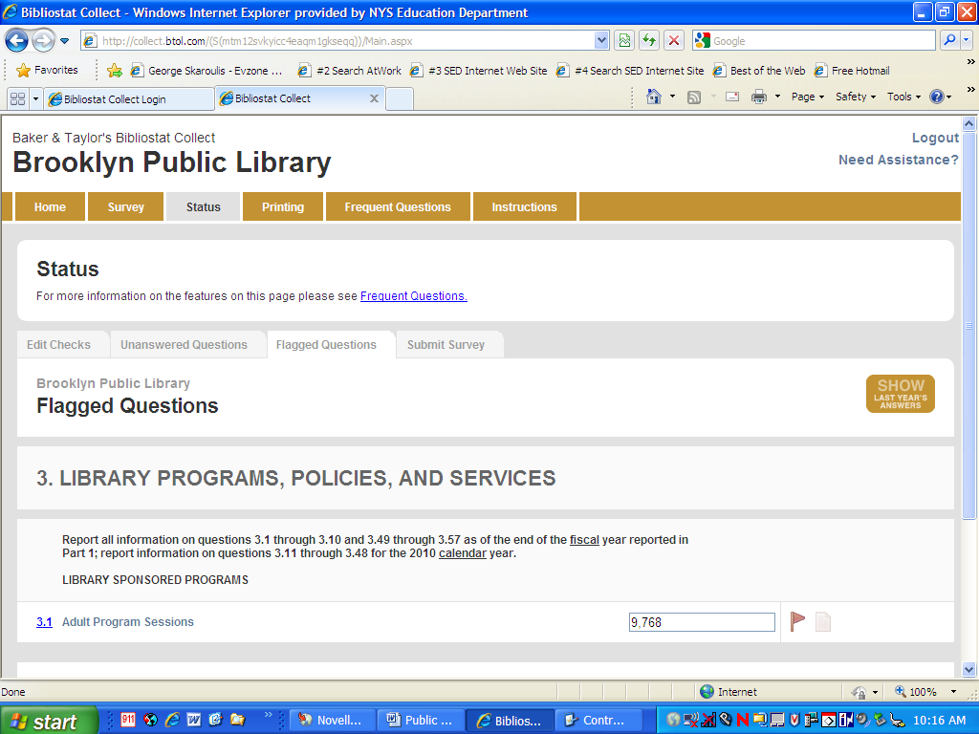
Clicking on the “Flagged Questions” tab will create a list of questions that had been flagged. Answers may be entered or revised from this screen – there is no need to go back into the annual report.
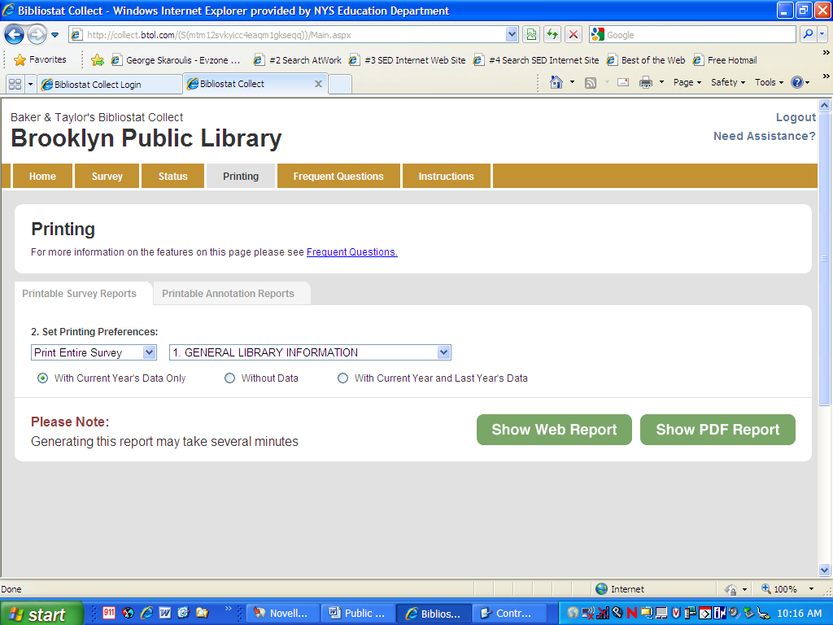
The final step before submission is to print and save a copy of the annual report. Click on the “Printing” tab, then click on the “Printable Survey Reports” tab; be certain that “Print Entire Survey” and “With Current Year’s Data” are selected. The .pdf version may take longer to load, but it is the best format for saving the annual report.
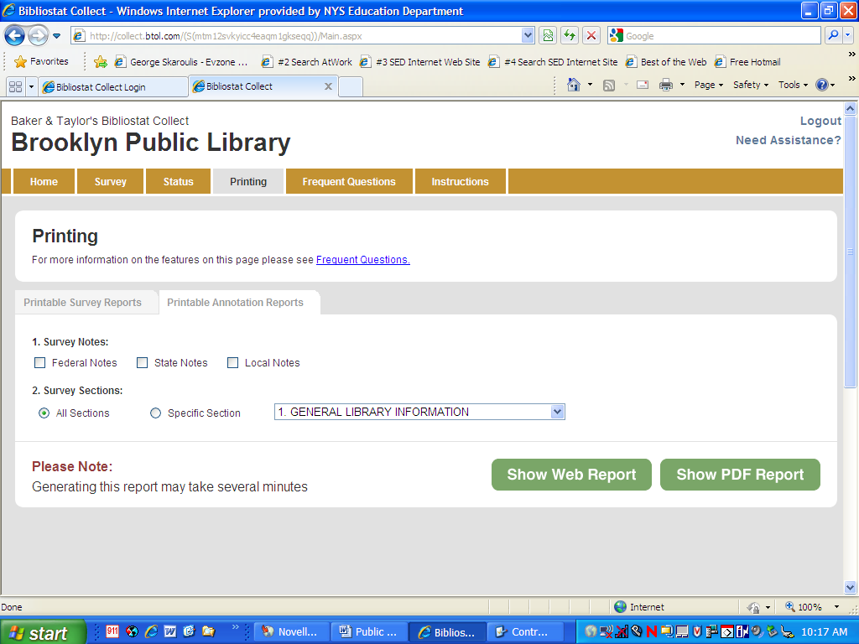
To create the annotation report, click on the “Printable Annotation Report” tab, and select the options desired – “Federal Notes”, “State Notes” and/or “Local Notes”; and “All” or a “Specific Section”.
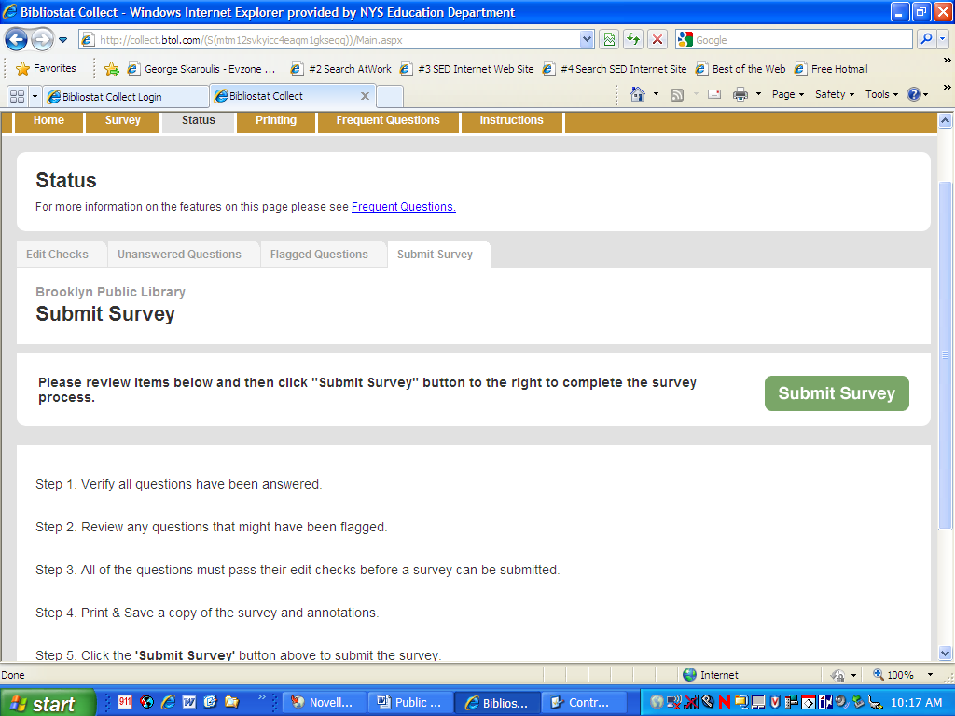
When ready to submit, go to “Status” and click on the “Submit Survey” tab. When all steps have been completed, click on “Submit Survey”. A dialog box will open asking if the user is sure he/she wants to submit. Click on “OK”.
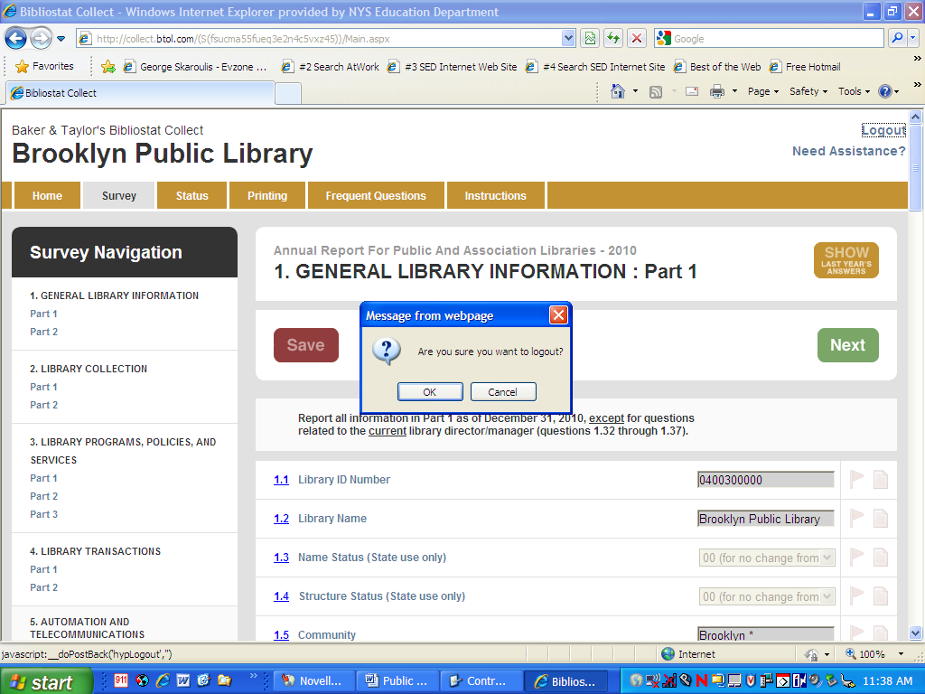
When exiting the software, click on “Logout”, then click on “OK”.

